**Database Development and Class Registration**

Theresa Musselman

The University of Arizona Global Campus

CST499: Capstone for Computer Software Technology (CSF2501A)

Professor Joseph Rangitsch

April 7, 2025

**Database Development and Class Registration**

The second phase of development for the Education Portal Management Website focused on enhancing the database and enrollment features in accordance with the Software Requirements Specification (SRS) document. The landing, registration, and login pages were successfully developed during the first phase. Additionally, the user table, depicted in Figures 1 and 2, was created and populated as part of phase one. This paper outlines the database architecture, website design, and the underlying logic implemented throughout the development process.

**Figure 1**

*EducationPortal Database User Table Structure*

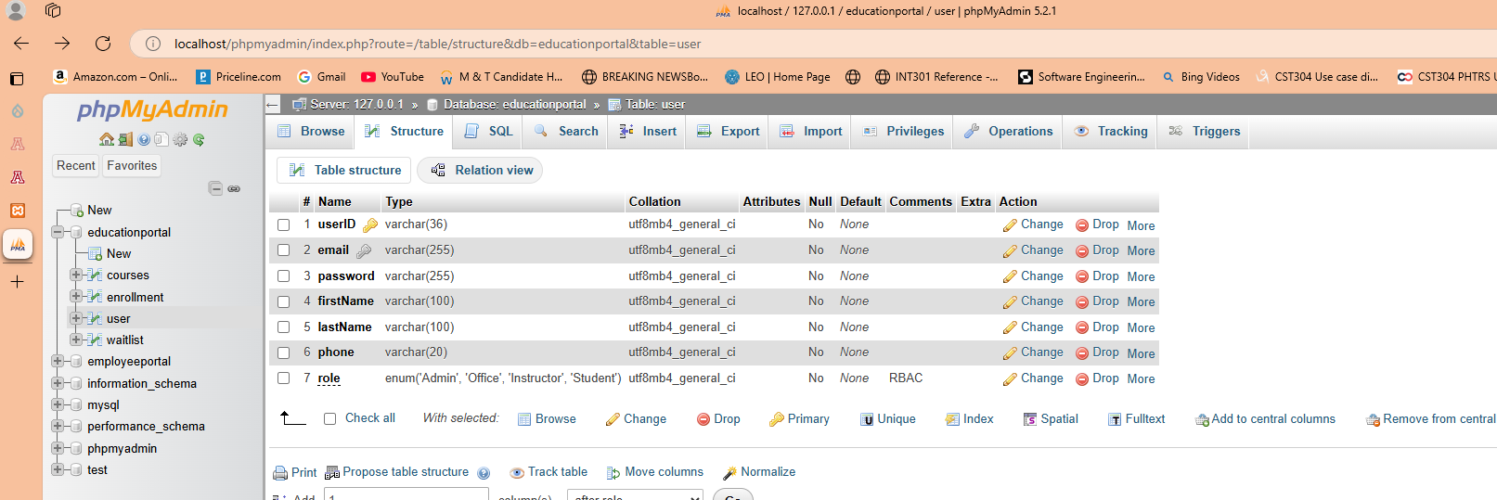

**Figure 2**

*EducationPortal Database User Table Records*

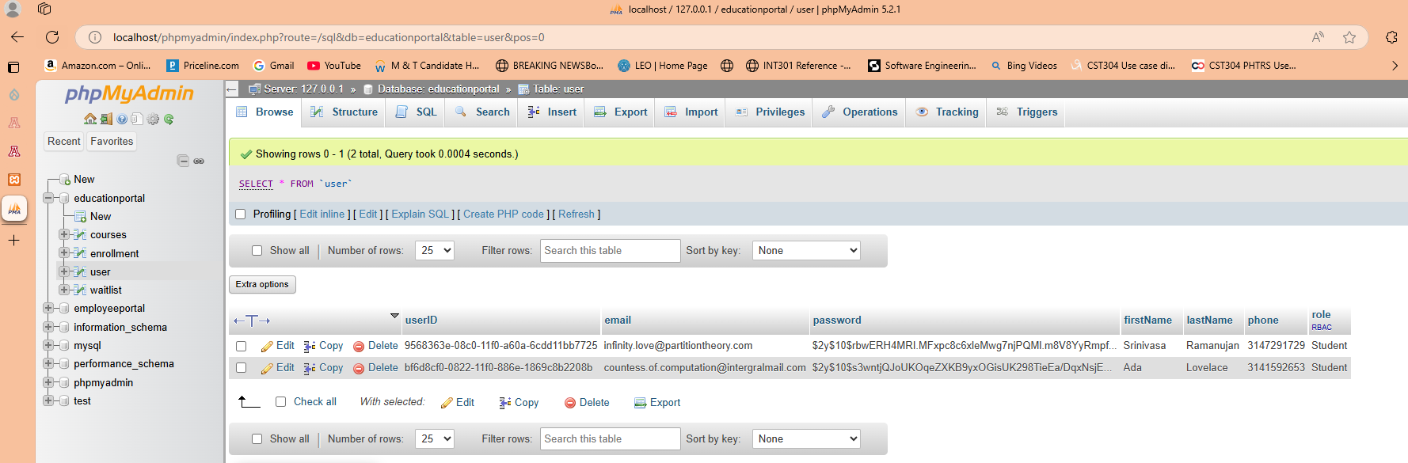

To commence the next phase, the courses table, shown in Figure 3, was populated with data as illustrated in Figure 4. During the initial development phase, the course table was created; however, it became evident that an additional "department" field was necessary to enhance functionality. This new field was essential to support the course search feature effectively. Initially, the courseID was intended as the primary reference for search functionality. However, organizing the data into distinct fields, such as the department, adheres to the principle of separation of concerns, simplifying the search logic and reducing complexity (Coronel & Morris, 2019).

**Figure 3**

*EducationPortal Database Courses Table Structure*

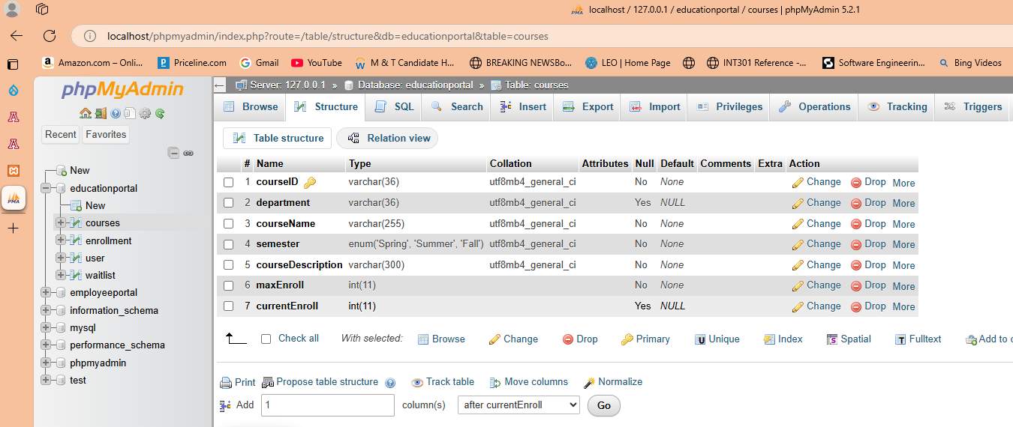

**Figure 4**

*EducationPortal Database Courses Table Records*

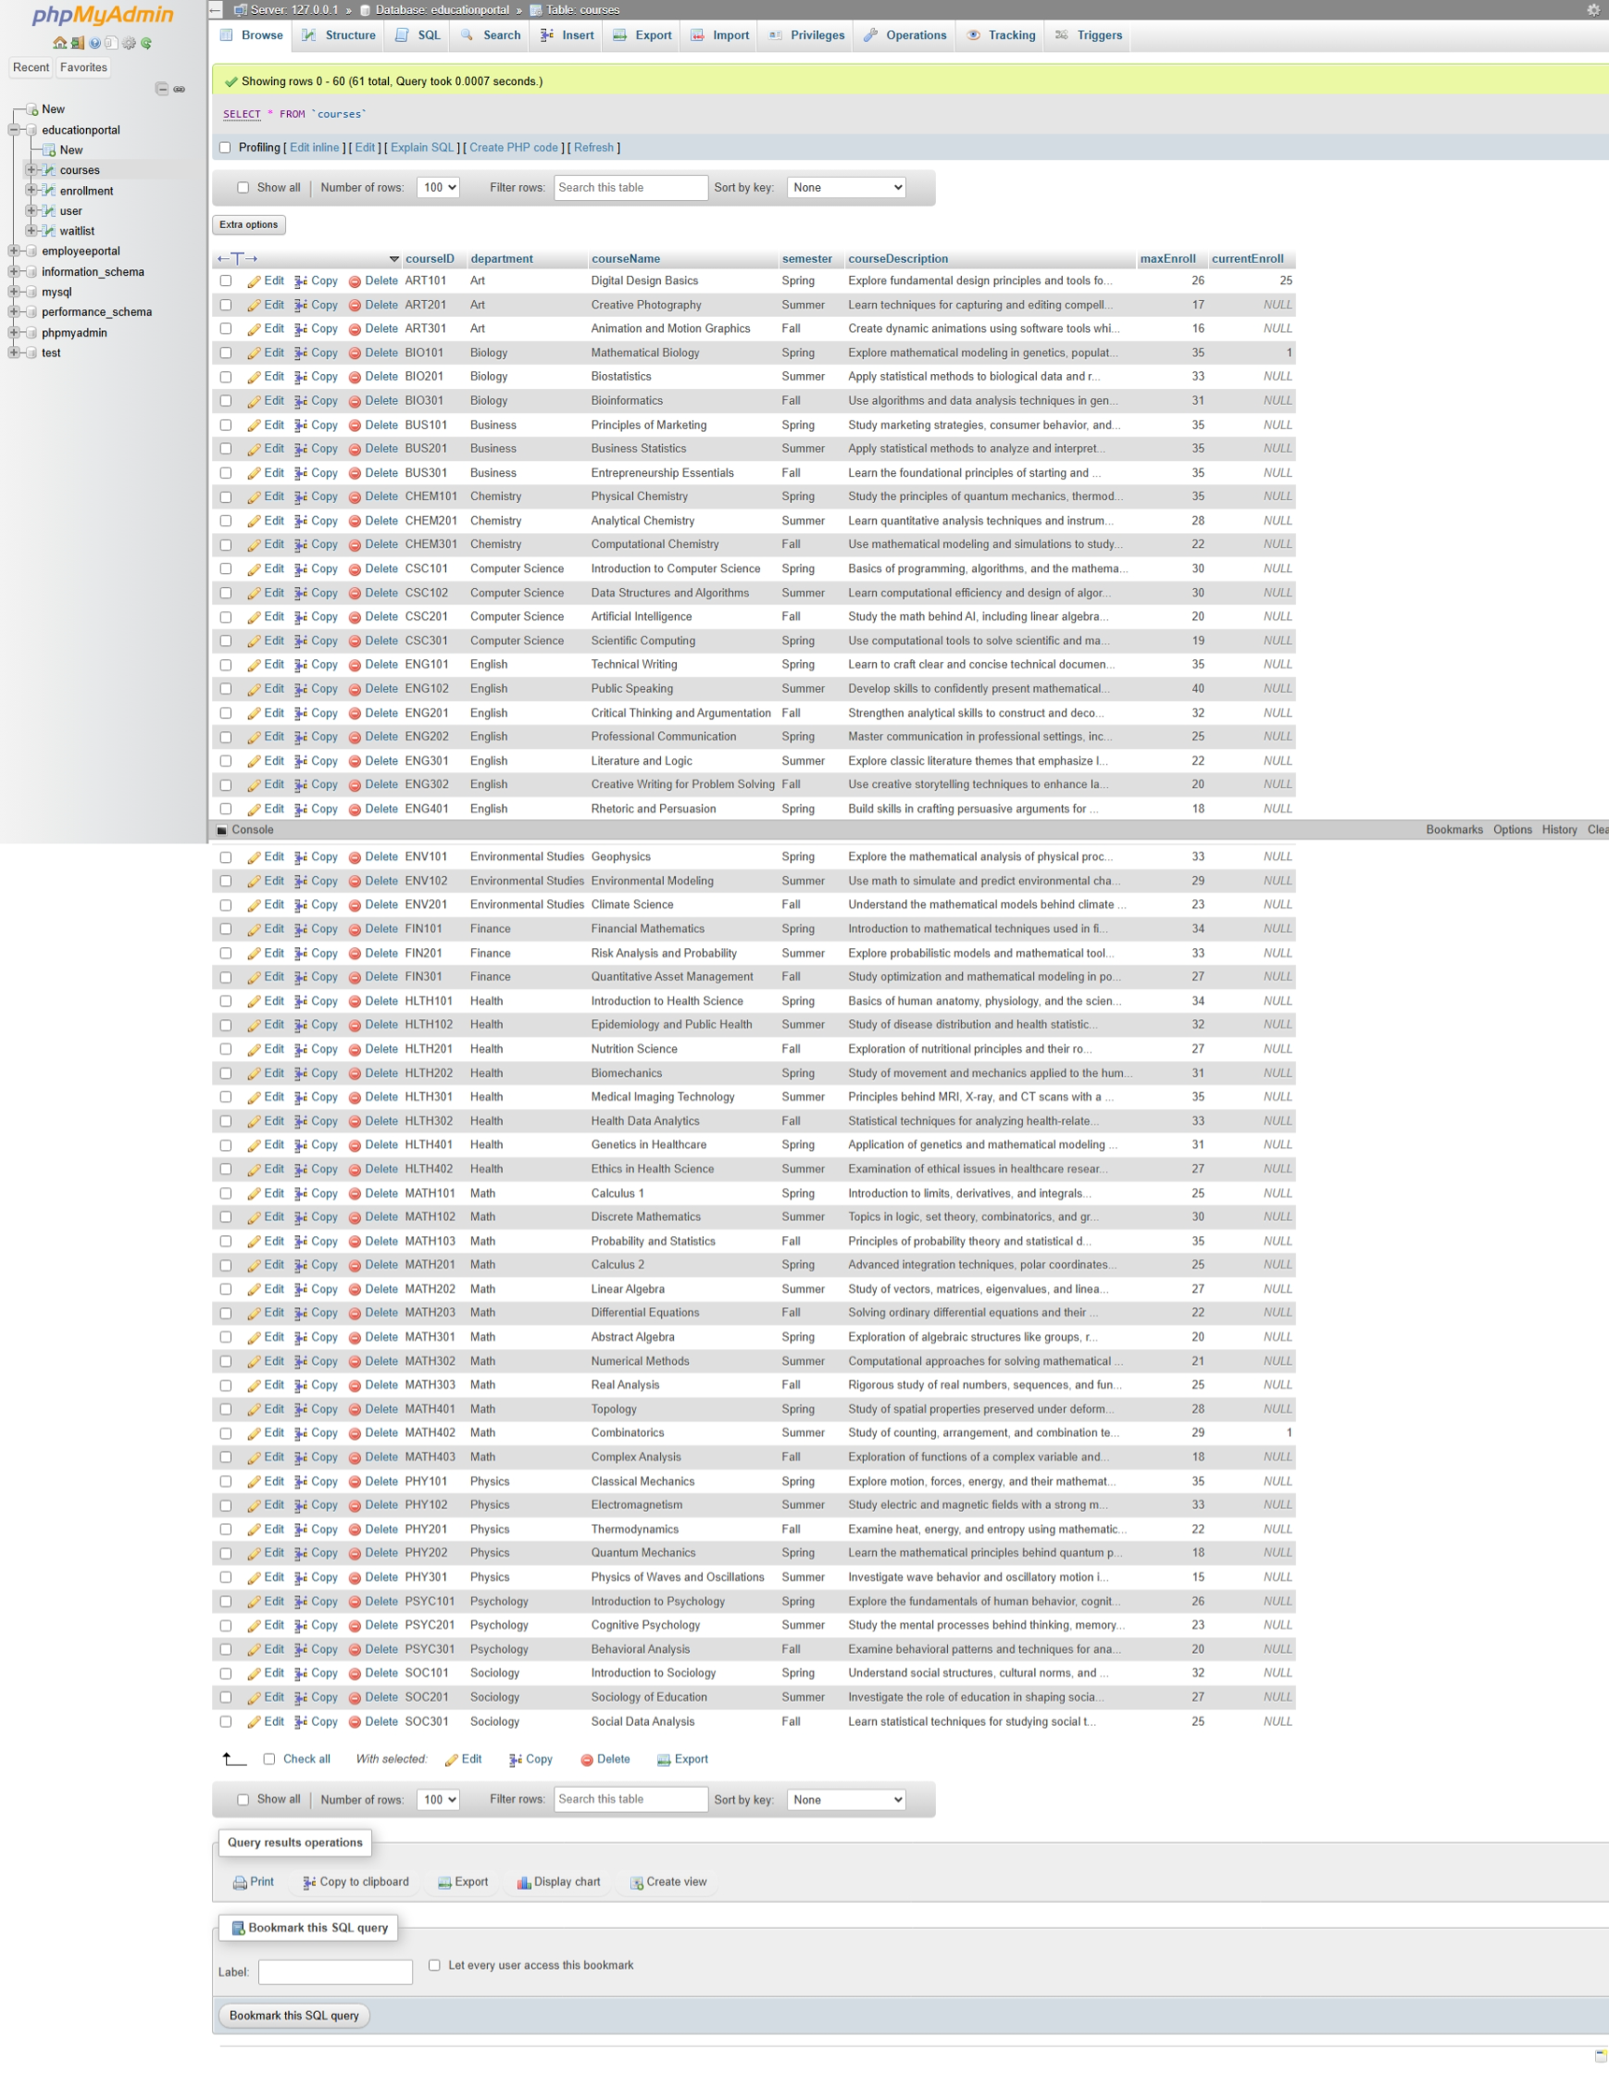

The courses.php script, illustrated in Figures 5 and 6, was developed as part of the front-end implementation. Initially, the design aimed to incorporate a search bar; however, further evaluation highlighted challenges such as extensive validation requirements and increased complexity associated with user-generated input. To address these issues, a toggle dropdown menu with checkboxes was implemented, allowing users to select both the semester and course departments. The script’s development drew upon W3Schools as a reference for guidance (W3Schools, n.d.). Additionally, adopting code reuse proved to be a reliable strategy, enhancing fault tolerance and mitigating security risks, including potential SQL injections (Tsui et al., 2018; Wills, 2022). A multi-select feature was also integrated, enabling students to search across multiple record types in a single query, thereby eliminating the need for separate, independent searches (MD Bootstrap, n.d.).

The development of this feature was both time-intensive and complex, particularly in addressing the placement of dropdown labels. The decision to display checkbox labels vertically added an additional layer of complexity to the script, as the default alignment for these labels is horizontal. As a result, customized CSS styling was required, as illustrated in the scripts provided in Figures 30 through 32. The search feature utilizes a form with a GET submission method, chosen because the backend exclusively performs SELECT queries to retrieve data from the database. Using GET rather than POST enhances performance, as the submitted data does not pose significant security risks (Coronel & Morris, 2019). Figure 7 highlights the courses page, presenting search options for the summer semester alongside selections for the Math, Physics, and Psychology departments.

**Figure 5**

*Courses.php Script*

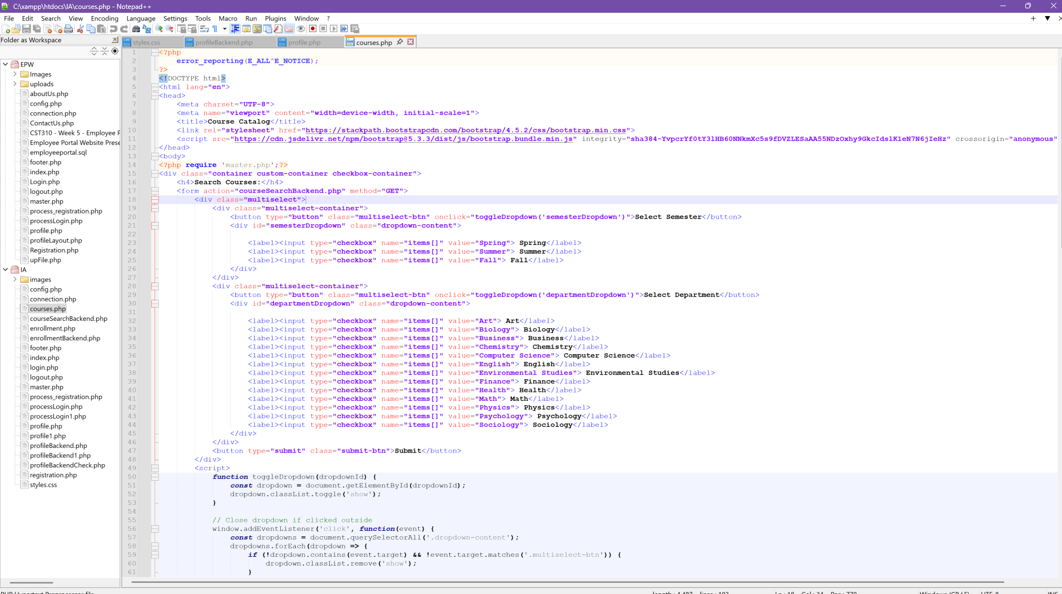

**Figure 6**

*Courses.php Script Continued*

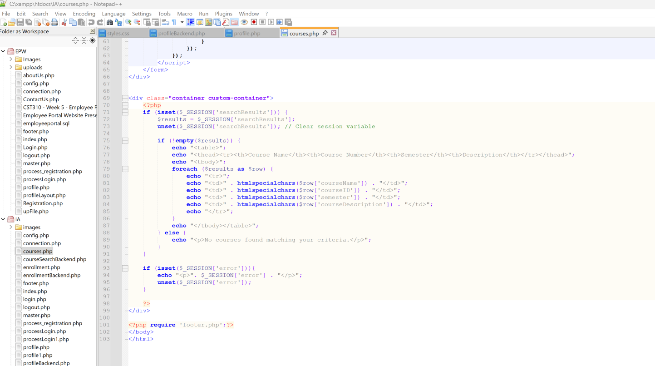

**Figure 7**

*Courses Page Search Selection*



The script for implementing the backend of the courses page is presented in Figures 8 and 9. Backend development began with connecting to the database using the config.php and connection.php files created during the first development phase. The search options selected on the form were retrieved from the GET array. It was then necessary to define two arrays, one for departments and another for semesters, so the items from the GET array could be sorted and separated. An if statement ensures that the $items GET array is not empty. If the array is empty, the else statement redirects the user back to the courses.php file with a message stating, “No courses found matching your criteria.”

A ‘for’ loop iterates through the items in the GET array. Semester-related elements are identified by an ‘if’ statement and added to the semester array, while other elements are placed in the department array. During the development process, debugging challenges arose. Additional methods like lower() and trim() were introduced to address these issues. However, these methods may become redundant during refactoring, as form inputs rely on checkboxes that inherently validate user input.

The search logic uses three ‘if/else’ statements to address all possible selection scenarios: (1) both courses and departments selected, (2) only departments selected, and (3) only courses selected. A whereClauses array was used to manage cases where both semester and department options were chosen. This approach leverages the fact that an array can store another array as an element (Miller et al., 205). These arrays are integral to forming the SELECT FROM WHERE query. Subsequently, the SQL query retrieves results stored in the $_SESSIONS array. The courses.php file then accesses this array to display the results in a table format on the courses page. Figure 10 presents the search results generated from the search options depicted in Figure 7.

**Figure 8**

*courseSearchBackend.php Script*

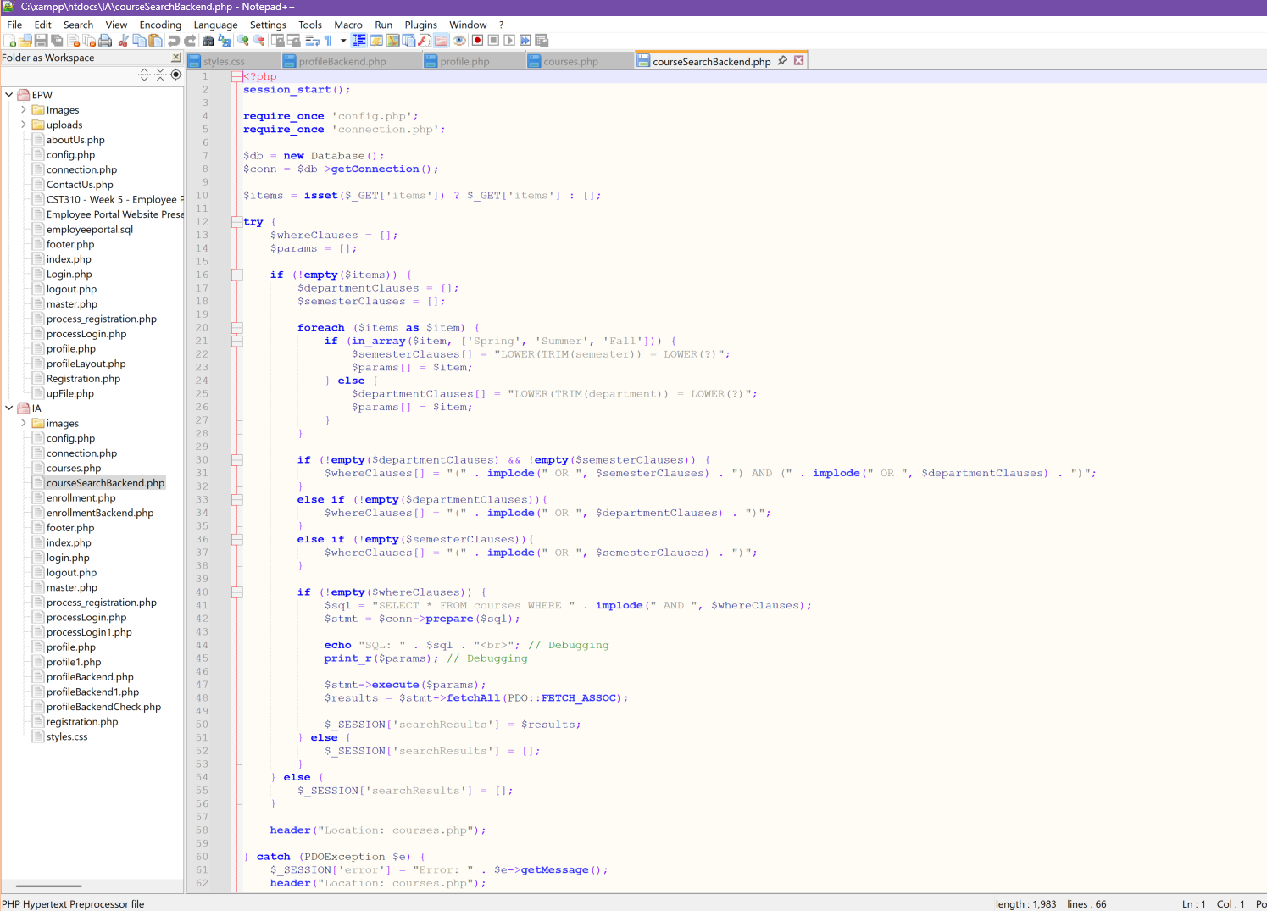

**Figure 9**

*courseSearchBackend.php Script Continued*

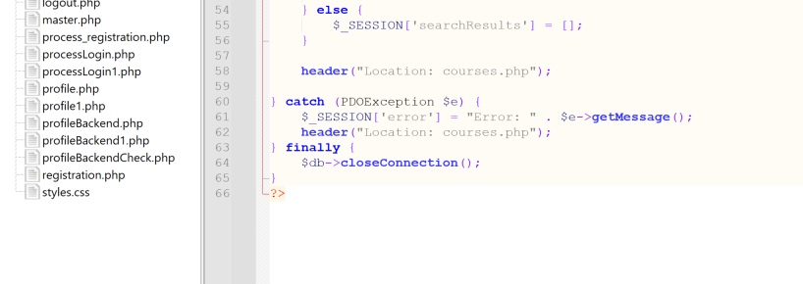

**Figure 10**

*Courses Page Search Results*

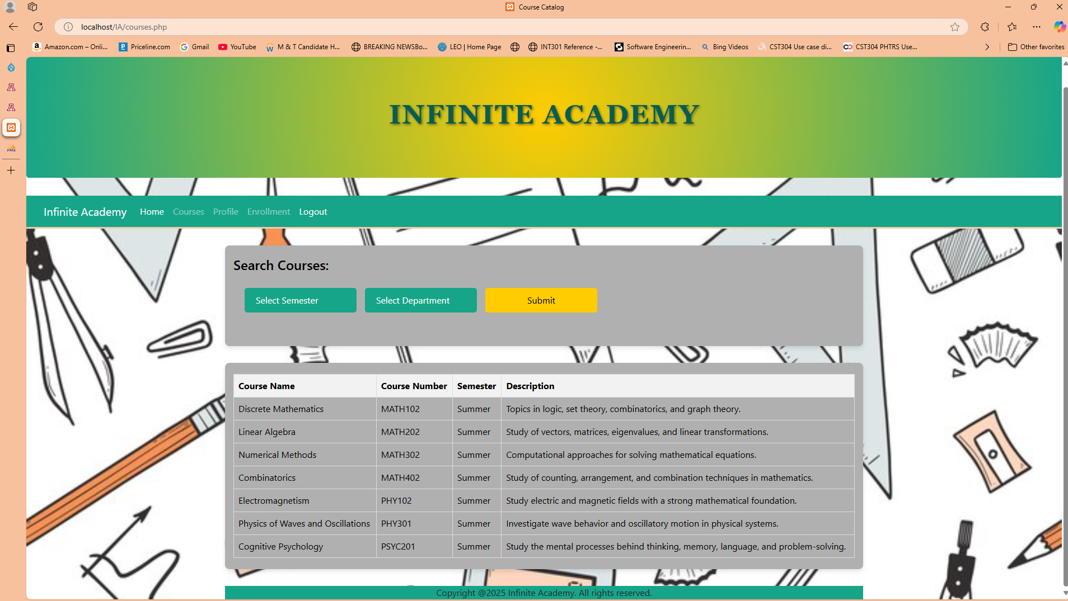

The course enrollment feature was developed next. Figure 11 illustrates the enrollment table structure in the educationPortal database, while Figure 12 displays the records stored within the table. The script for the enrollment page is presented in Figure 13. To ensure that only registered students can enroll in courses, access to this page is restricted to logged-in users. Additionally, the backend script validates the user's role as a "student." As implemented in the database and depicted in Figure 1, role-based access control enables this functionality and supports the school’s business logic to support the software requirements (Pressman & Maxim, 2020). The enrollment.php files utilize a form similar to the one designed for the registration page to collect user data. The POST method was chosen for form submission to ensure the security of enrollment data and facilitate the backend script’s ability to insert this information into the database (Coronel & Morris, 2019). Figure 14 shows the enrollment page with the user's information and chosen course for enrollment.

**Figure 11**

*EducationPortal Database Enrollment Table Structure*

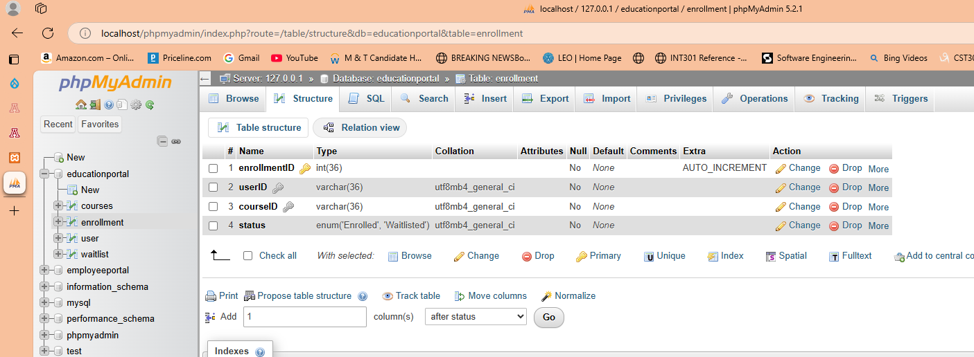

**Figure 12**

*EducationPortal Database Enrollment Table Before New Enrollment*

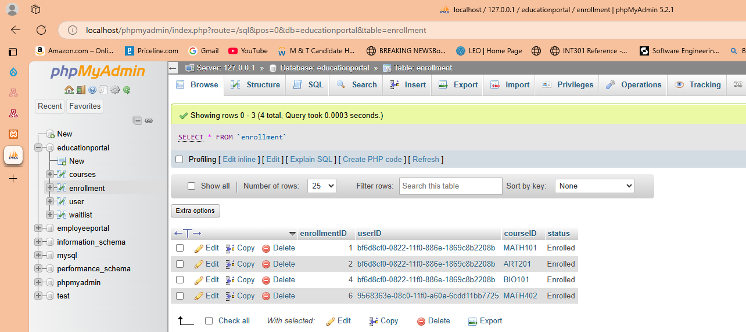

**Figure 13**

*Enrollment.php Script*

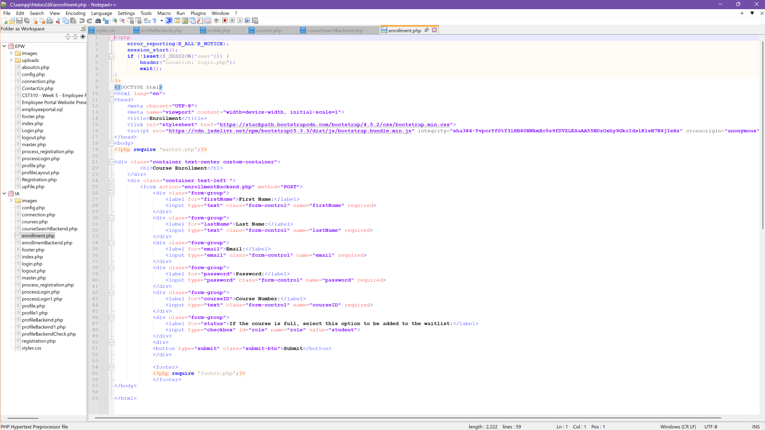

**Figure 14**

*Enrollment Page - New Enrollment*



Figures 15 and 16 present the script for the enrollmentBackend.php. First, a connection to the database is established by accessing the config.php and connection.php files. The form input is then validated using a method similar to the one employed in the process_registration.php. An if statement ensures that the courseID is not empty. This step was added later in the development process to address debugging issues and ensure the script functions reliably during course enrollment. Next, a SELECT statement retrieves the student's user data and stores it in the users array. The user array and the password_verify function are used to validate the user's credentials, similar to the approach in processLogin.php. Since the password is hashed, password_verify is necessary to compare the user's input with the hashed password stored in the database.

The script then retrieves the course details from the courses table in the database, storing them in the courseData array. If the query returns no results, an if statement is used to display an error message to the user. The script then checks whether the maximum enrollment capacity is greater than the current enrollment capacity using an if/else statement. If the current enrollment capacity is below the maximum capacity, the nextEnroll value is set to one more than the current capacity to accurately reflect the updated data in the currentEnroll field. An INSERT statement then adds the student to the enrollments table in the database. After the student is successfully added, the script redirects the user to their profile page.

If the course has reached its maximum capacity, the else statement ensures that the student is added to the waitlist table. A SELECT query uses the MAX function to identify the highest value in the queueOrder field. The waitlist table contains all students placed on the waitlist for any class at maximum capacity. Therefore, the script searches the waitlist table for the record that matches the courseID and has the maximum queueOrder value. NextQueueOrder is then defined as one more than the maxQueueOrder to ensure the new record is assigned the appropriate order on the waitlist. An INSERT query is subsequently executed to add the student to the waitlist table. The script then informs the user via a message that they have been successfully added to the waitlist. If the initial user validation fails, the else statements at the bottom of the script display an error message and redirect the user to the login page.

Figure 17 displays the enrollment table after the enrollment process shown in Figure 14 was completed. In Figure 3, the courses table indicated that MATH202 had no current enrollment records, and the currentEnroll field was NULL. Figure 18 demonstrates that the currentEnroll field in the courses table was updated during the enrollment process. Figure 19 shows that the courses table updated the ART101 record, setting the currentEnroll field to match the maxEnroll field, indicating that the course reached full capacity. Figure 20 illustrates a student attempting to enroll in the ART101 course. Figure 21 presents the message informing the student that the course is at full capacity and that they have been added to the course waitlist with a queue number of 2. Figure 22 outlines the structure of the waitlist table, while Figure 23 confirms that the new record was added to the table with a queue order of 2.

**Figure 15**

*EnrollmentBackend.php Script*

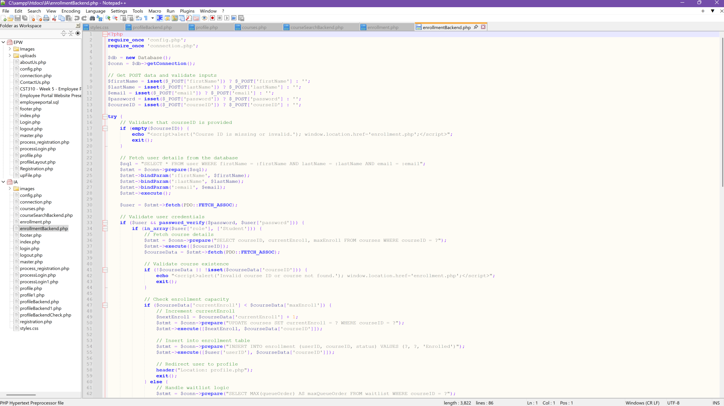

**Figure 16**

*EnrollmentBackend.php Script Continued*

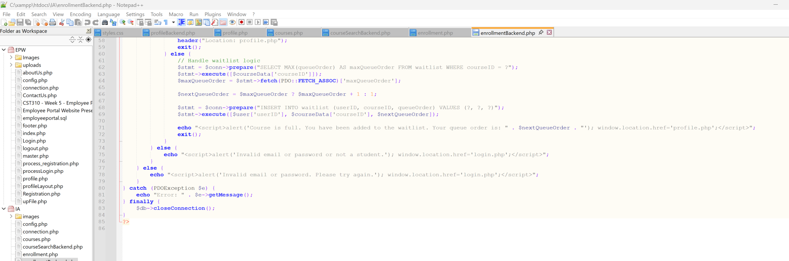

**Figure 17**

*EducationPortal Database Enrollment Table After New Enrollment*

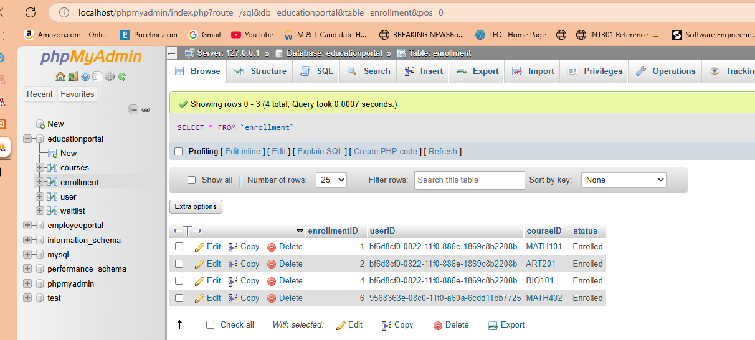

**Figure 18**

*EducationPortal Database Courses Table currentEnroll Field Update After New Enrollment*



**Figure 19**

*Course Enrollment ART101 at Max Enrollment Capacity Course Table*



**Figure 20**

*Course Enrollment for ART101 Course at Max Enrollment*

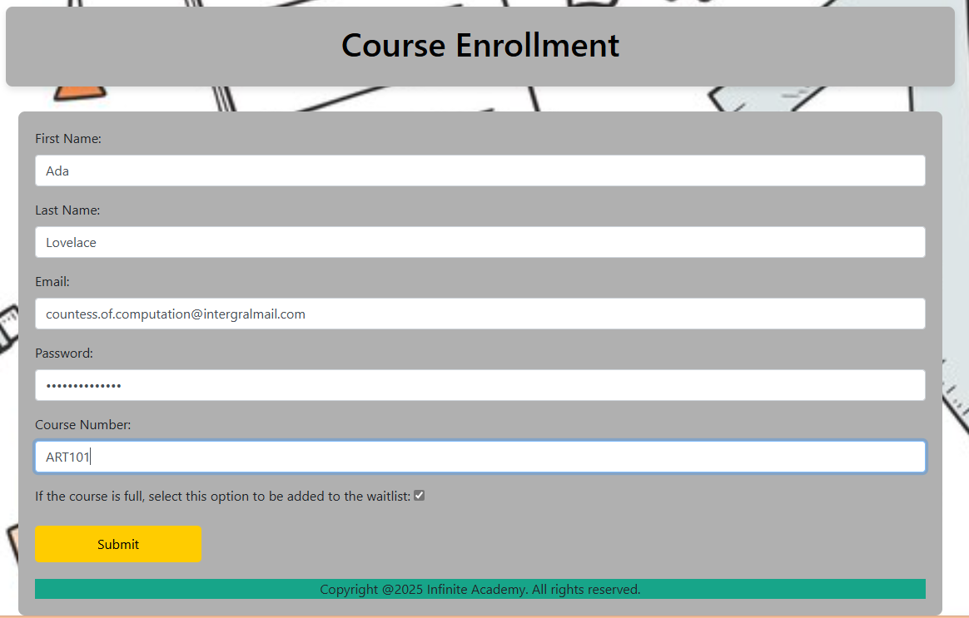

**Figure 21**

*Course at Full Capacity – Waitlist Message*

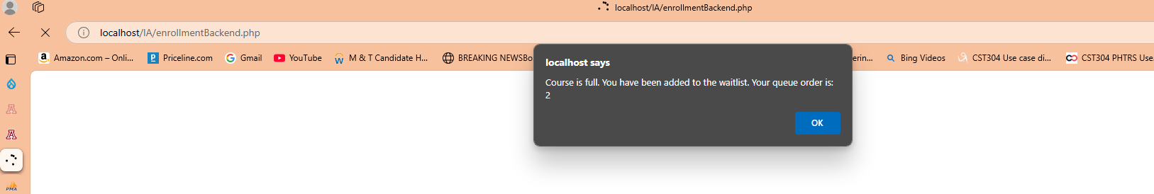

**Figure 22**

*Waitlist Table with New Record Added*

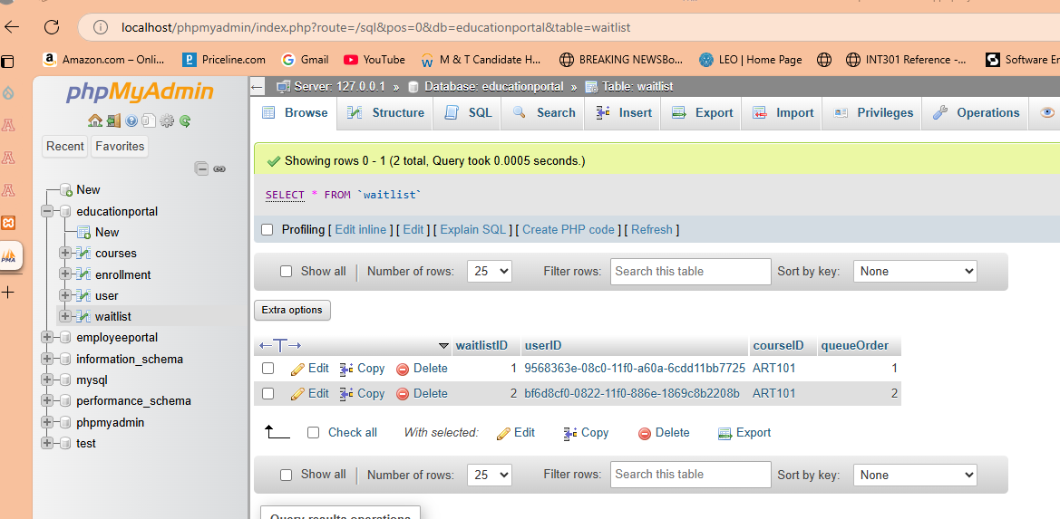

**Figure 23**

*EducaionPortal Database Waitlist Table After New Record Added*

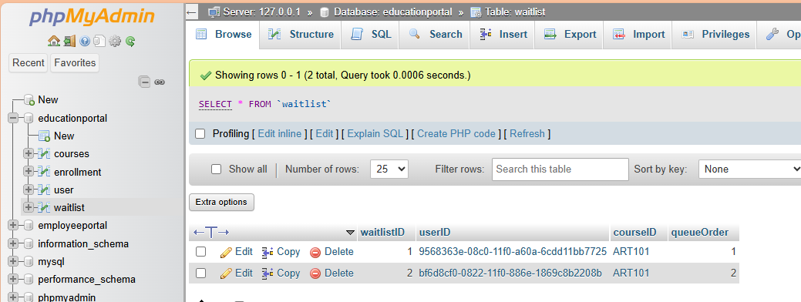

The profile page in Figure 24 confirms that the student’s enrollment was successful and is now visible under their current courses on their profile page. The script for the profile page is detailed in Figures 25 and 26. Similar to the enrollment page, it is crucial to validate that only an in-session user can access the profile page. This validation upholds the principles of the CIA triad: confidentiality, integrity, and availability, ensuring a secure and reliable user experience (Wills, 2022). Several approaches were attempted when developing this page. Initially, all logic was implemented in the backend. However, this led to critical errors when attempting to retrieve the session user's current courses from the database. To resolve this issue, the logic was shifted to the profile.php page. After establishing the database connection, a 'try' block was utilized to execute a SELECT query. This query retrieved the courseIDs for the session user from the enrollment table and stored them in the enrollments array. A course array was then initialized. An if statement was used to make a SELECT query to retrieve course details for the enrolled courses and store them in the courses array. The courses array was used in the HTML body to populate the current course table. The current course table also allows the student to delete (unenroll) a course. In the table, a form with the POST method was used to provide the delete button.

**Figure 24**

*Profile Page*

**

**Figure 25**

*Profile.php Script*

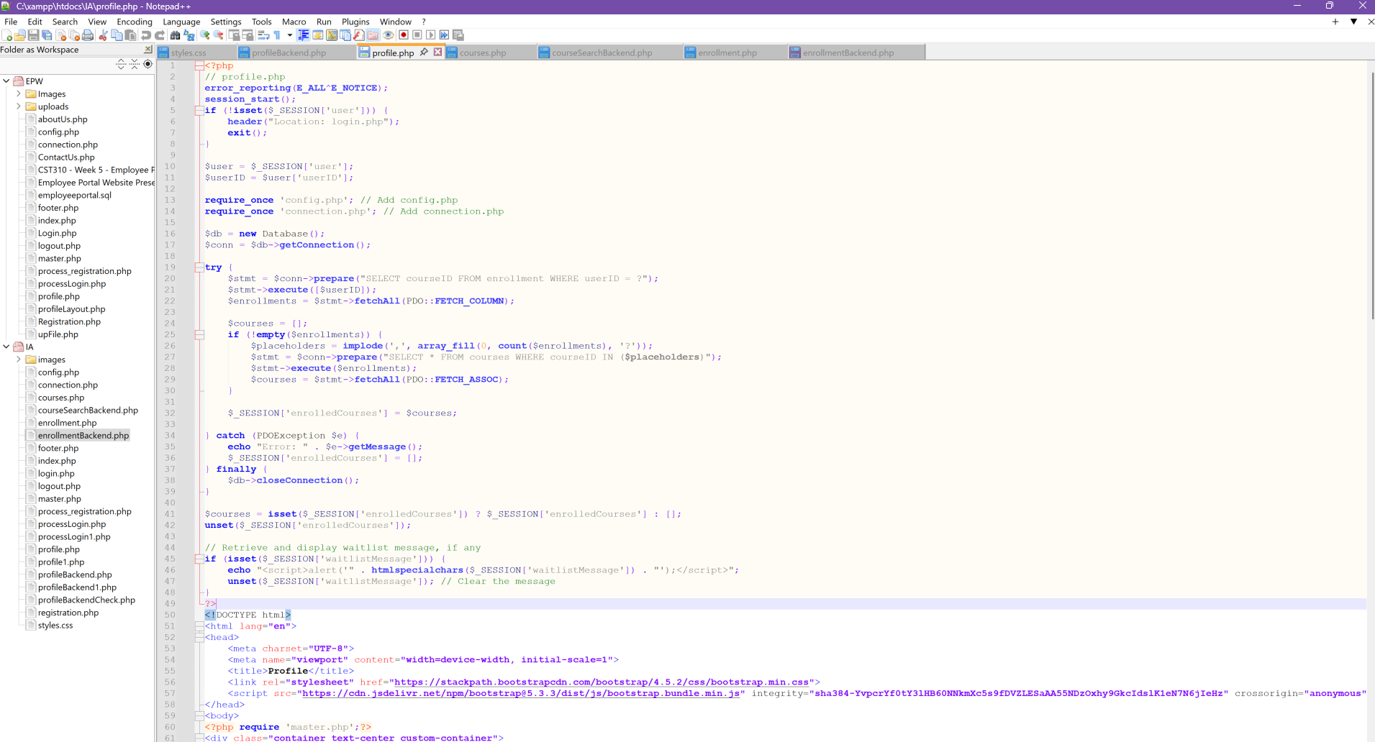

**Figure 26**

*Profile.php Script Continued*

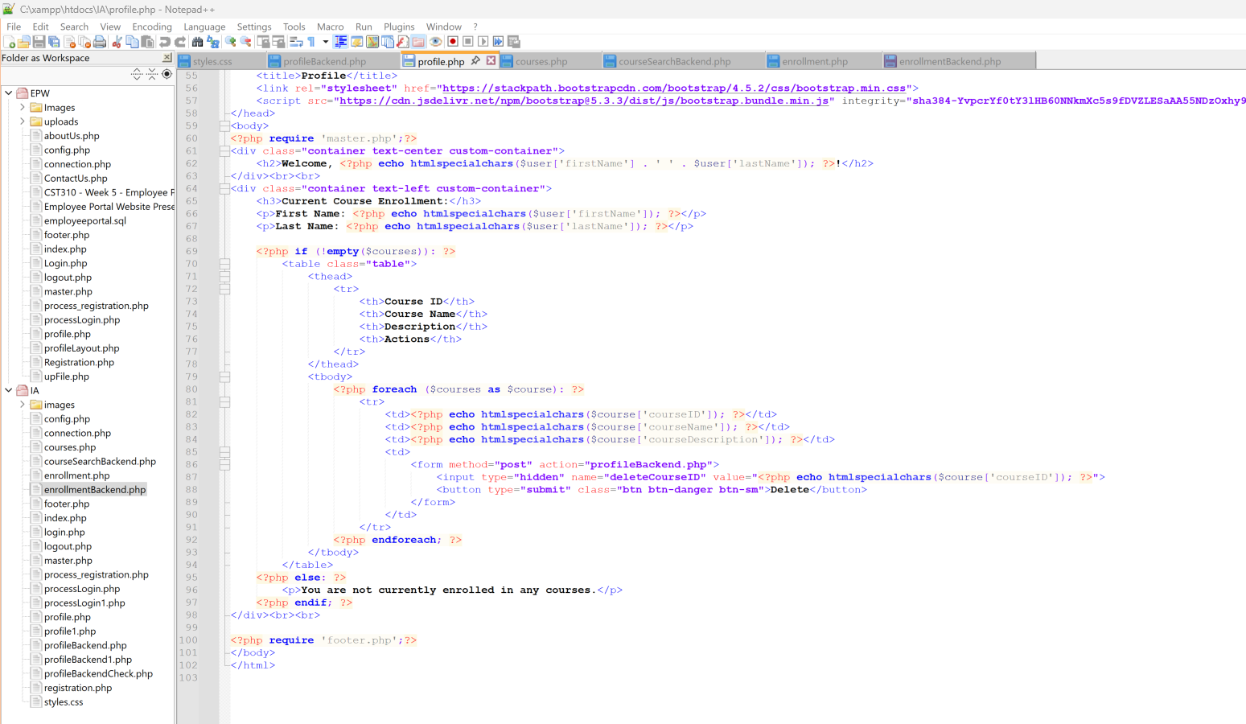

Figure 27 presents the profileBackend.php script. After establishing a connection to the database, the deleteCourseID array stores information from the form. A DELETE statement is then executed to remove the record that matches both the userID and courseID. Following this, an UPDATE query is performed to decrease the course's current enrollment by one. A subsequent SELECT query checks the database waitlist, and the query results are stored in the courseData array. The courseData is then used to SELECT waitlist records matching the userID and courseID. An if statement stores the message “A spot has opened” in the $_SESSIONS array. Figure 28 demonstrates that the course shown in Figure 24 was successfully deleted and is accurately reflected in the current courses table on the user profile page. Figure 29 confirms that the course table in the database now shows zero in the currentEnroll field.

**Figure 27**

*profileBackend.php*

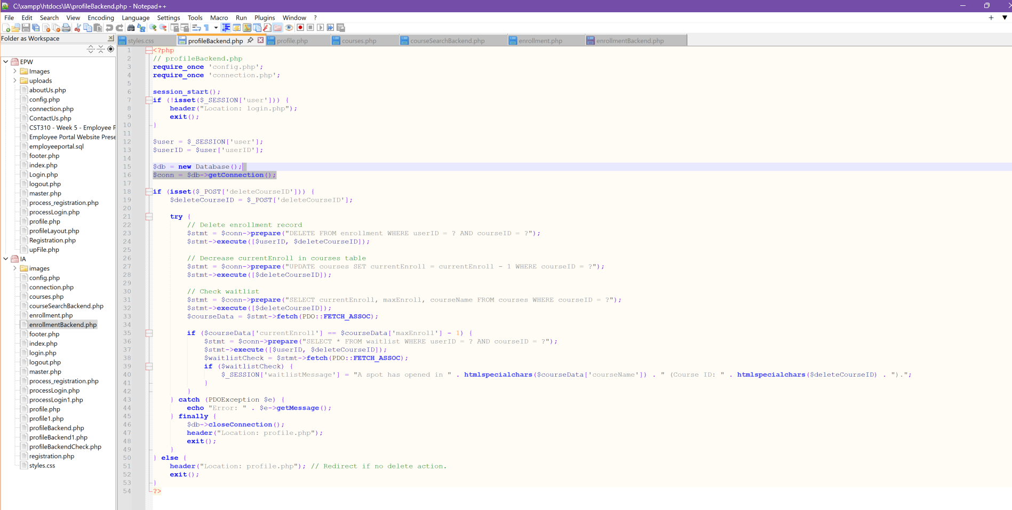

**Figure 28**

*Profile Page After MATH202 Delete Action*



**Figure 29**

*Courses Table Update After Course Deletion Updated*



**Figure 30**

*Styles.css Script*

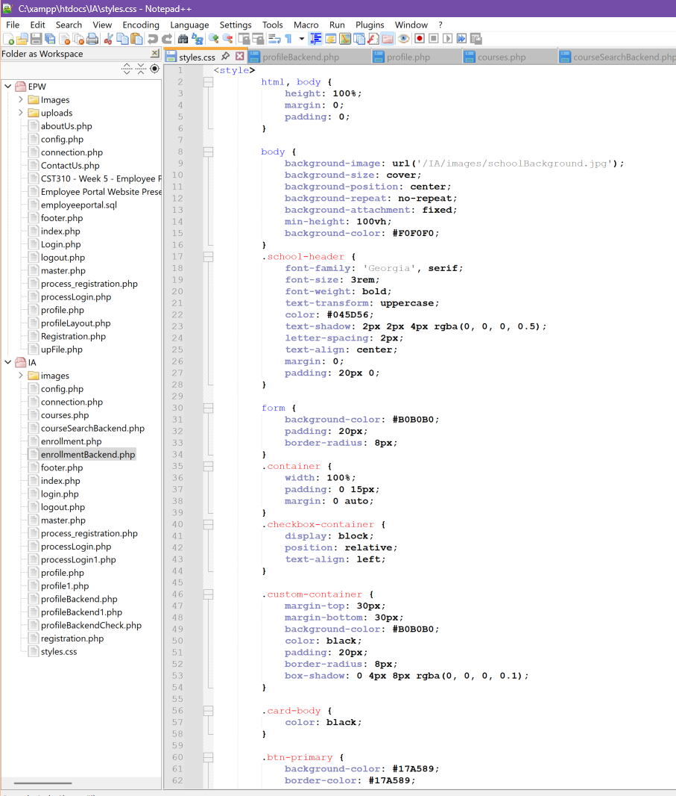

**Figure 31**

*Styles.css Script Continued*

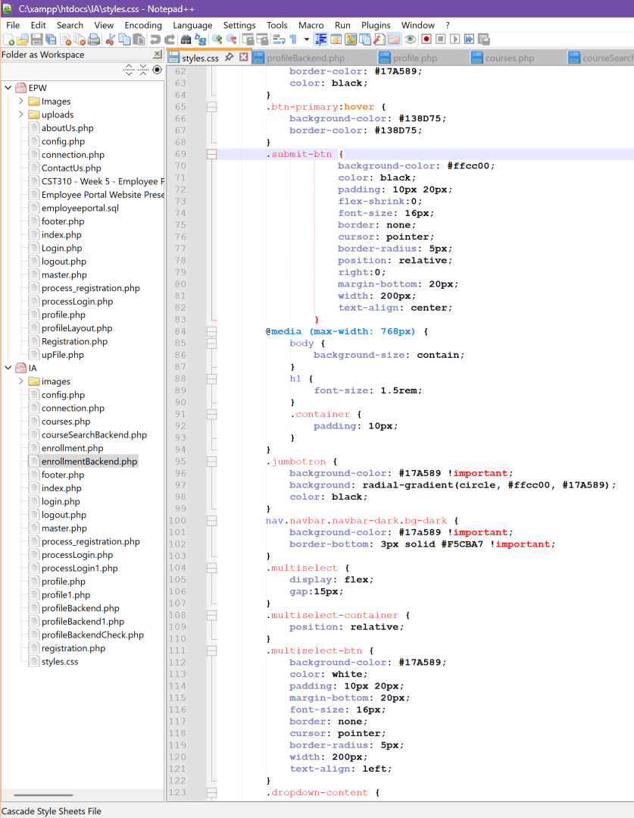

**Figure 32**

*Styles.css Script Continured 2*

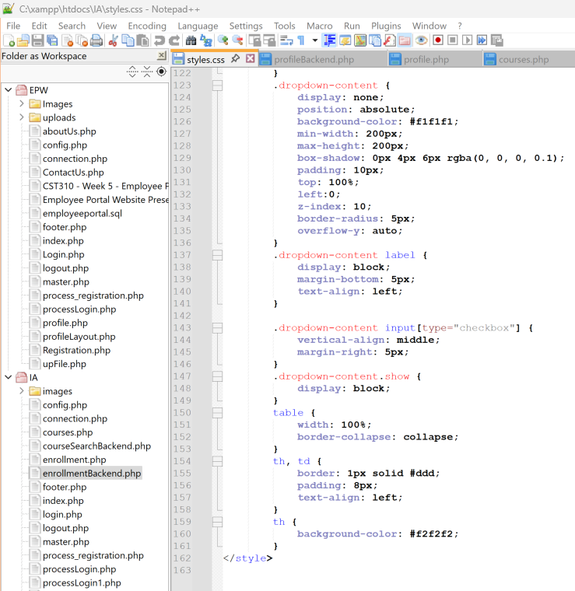

In conclusion, this development phase provided valuable insights into database integration and front-end design complexities within a web application. The process of implementing course enrollment and search functionalities highlighted the importance of careful planning, thorough testing, and flexible problem-solving. Debugging challenges, particularly related to data validation and session management, reinforced the need for meticulous coding practices. Ultimately, the successful deployment of these features demonstrates the practical application of web development principles and the ability to adapt to evolving project requirements.

**References**

Connolly, R., & Hoar, R. (2022). [*Fundamentals of Web Development*](https://uagc.instructure.com/courses/139145/modules/items/7107299) (3rd Ed.). Pearson.

Coronel, C., & Morris, S. (2019). [*Database Systems: Design, Implementation, and Management*](https://uagc.instructure.com/courses/130144/modules/items/6620787)

(13th Ed.). Retrieved from <https://www.vitalsource.com>

MD Bootstrap. (n.d.). MultiSelect. Retrieved April 1, 2025, from

[Bootstrap Multiselect - free examples, templates & tutorial](https://mdbootstrap.com/docs/standard/extended/multiselect/)

Miller, B., Vahid, F., & Lysecky, R. (2015). [*Programming in Python 3*](https://uagc.instructure.com/courses/122649/modules/items/6235370). zyBooks.

Pressman, R. S., & Maxim, B. R. (2020). [*Software Engineering: A Practitioner's Approach*](https://uagc.instructure.com/courses/135525/modules/items/6902398) (9th

Ed.). Retrieved from <https://www.vitalsource.com>

Tsui, F., Karam, O., & Bernal, B. (2018). [Essentials of Software Engineering](https://uagc.instructure.com/courses/143469/modules/items/7317752) (4th ed.). Jones &

Bartlett Learning.

W3Schools. (n.d.). *Bootstrap JS Dropdown.* W3Schools. [Bootstrap JS Dropdown Reference](https://www.w3schools.com/Bootstrap/bootstrap_ref_js_dropdown.asp)

Wills, M. (2022). [(ISC)2 SSCP Systems Security Certified Practitioner Official Study Guide.](https://search.ebscohost.com/login.aspx?direct=true&AuthType=shib&db=nlebk&AN=3137727&site=eds-live&scope=site&custid=s8856897&ebv=EB&ppid=pp_C1)

(3rd ed.). Wiley Professional Development (P&T).